Build an event management system using sales force

**Introduction**

**Event management is the process of creating and maintaining an event. This process spans from the very beginning of planning all the way to post-event strategizing.**

**At the start, an event manager makes planning decisions, such as the time, location, and theme of their event. During an event, event managers oversee the event live and make sure things run smoothly. After an event, event managers are tasked with reviewing event data, submitting KPI and ROI findings, and staying on the ball for any post-event offerings.**

**All different branches of planning go into event management, including various types of sourcing, designing, regulation checks, and on-site management. In event management, you could be in the process of creating a conference, a product launch, an internal sales kick-off, or even a wedding. Really, any event that requires considerable planning and execution is event management.**

**General sales forces event management**

Your event management software should help you keep track of every aspect and step of the event-planning process.

[**When selecting your Salesforce app**](https://events.fonteva.com/best-salesforce-apps/)**, look for a solution that can equip you with tools to manage all of the following:**

* Venue
* Sponsors
* Speakers
* Exhibitors
* Sessions
* Tracks

### Salesforce Attendee Management

Consider the event experience from your guests’ points of view. Attendee satisfaction goes hand in hand with a good event management platform.

**Streamline registration, scheduling, and other event logistics by finding software that can assist with the following:**

* Event Schedules
* Attendee Agendas
* Waitlists
* RSVP Management
* Table and Seating Assignments

### Salesforce Event Promotion

#### **Event Microsites**

[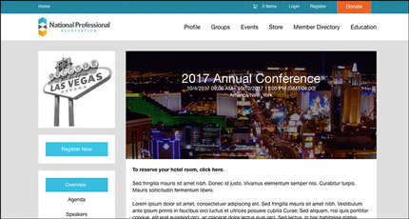](https://events.fonteva.com/wp-content/uploads/2017/06/salesforce-event-microsite.jpg)

Some event management apps generate dedicated webpages (or microsites) to serve as the hub for all things related to your event.

A microsite is ideal for promoting your event. You can post all relevant event information in one location *and*accept registrations or sell tickets, too. It also helps you track leads, giving you better insight into how attendees find your event. Don’t forget to include an eStore to sell merchandise or other items!

#### **Event Registration**

[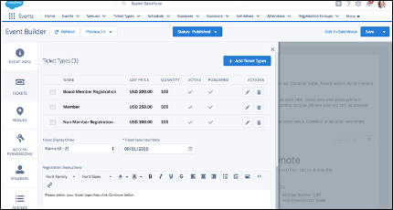](https://events.fonteva.com/wp-content/uploads/2017/06/event-registration.png)

#### **Event Microsites**

[](https://events.fonteva.com/wp-content/uploads/2017/06/salesforce-event-microsite.jpg)

Some event management apps generate dedicated webpages (or microsites) to serve as the hub for all things related to your event.

A microsite is ideal for promoting your event. You can post all relevant event information in one location *and*accept registrations or sell tickets, too. It also helps you track leads, giving you better insight into how attendees find your event. Don’t forget to include an eStore to sell merchandise or other items!

#### **Event Registration**